SECTION 1: INVITATION FOR BIDS

1.1 Introduction
Sealed bids are invited from Bidders for the supply and installation of machines for the production of bamboo animal feed including 6 months of onsite comprehensive warranty support. The bids should be submitted in the prescribed format at the address mentioned.

1.2 Schedule of Bid Process
Sl. No. | Information Details
1 | RFP No. and Date: No. NECBDC/Animal Feed/322/2024, Date:16/10/2024
2 | Bid validity period: 180 days from the date of opening of technical Bid
3 | Last date for submission of bids: 15th November,2024
4 | Opening of Technical Bid: 18th November,2024
5 | Opening of Commercial Bid: 19th November,2024

1.3 Instructions to Bidders
Bidders are advised to study this RFP document carefully before participating. It shall be deemed that the submission of bid by the bidder has been done after their careful study and examination of the RFP with a full understanding to its implications. Any lack of information shall not in any way relieve the bidder of his responsibility to fulfill his obligations under the Bid.
1.3.1 Cost of Bidding
Bidder shall bear all costs associated with the preparation and submission of the Bid. NECBDC will in no case be responsible or liable for those costs, regardless of the conduct or outcome of the bidding process.
1.3.2 RFP Document
Bidder is expected to examine all instructions, forms, terms, specifications, and other information in the RFP document. Failure to furnish all information required by the RFP document or to submit a Bid not substantially responsive to the RFP document in every respect will be at Bidder’s risk and may result in the rejection of its Bid.
1.3.3 Language of BID
The bid prepared by the bidder, as well as all correspondence and documents relating to the Bid exchanged between the bidder and NECBDC, shall be in English.

1.3.4 Period of Validity of Bids
The bid shall remain valid for 1 year from the date of opening of technical bid. Bidder should ensure that in all circumstances, its Bid fulfils the validity condition. Any bid valid for a shorter period shall be rejected as nonresponsive. In exceptional circumstances, prior to expiry of the original proposal validity period, NECBDC may request the Bidders to extend the period of validity for a specified additional period. The request and the responses thereto shall be made in writing to or by facsimile to the listed contact information of the Bidders. In such cases, the Bidders shall not be required or permitted to modify the Proposal, but shall be required to extend the validity of the Proposal for the extension period.
1.3.5 Format and Signing of Bids
The bidder shall prepare required number of copies (original plus one copy) of the bid and shall clearly mark each as “Original Bid” or “Copy of Bid” as appropriate. In the event of any discrepancy between them, the original shall govern. The original and all copies of the bid shall be typed or written in indelible ink and shall be signed by the bidder or a person duly authorized to bind the bidder to the bid. The complete bid shall be without alteration or erasures, except those accorded with instructions issued by NECBDC or as necessary to correct errors made by the Bidder, in which case such corrections shall be initiated by the person or persons signing the bid.
1.3.6 Sealing and Marking of the Bid
Bidder shall submit their bids in THREE PARTS, each in a separate sealed envelope super-scribed with the RFP document number, due date, time, Project name and nature of bid (Technical or Commercial Bid).
PART-I: Original and 1 copy of TECHNICAL BID complete with all details.
PART-II: Original and 1 copy of COMMERCIAL BID with full price details
1.3.7 Pre-bid meeting
There will be no pre-bid meeting held. However, any query related to the tender document, bidder may please send an email to NECBDC at necbdc@gmail.com on or before 7 days after the publishing of the tender document.
1.3.8 Bid Due Date
Bid must be received by NECBDC at the address and not later than the time and date specified for this tender. Bids received after this deadline will be rejected and returned to the bidder unopened.
1.3.9 Late Bid
Bids received after the due date and the specified time (including the extended period if any) for any reason whatsoever, shall not be entertained and shall be returned unopened.
1.3.10 Bid Currency
Prices for services offered shall be quoted in Indian National Rupees only.
1.3.11 Bid Security
- All bidders shall furnish, an Earnest Money amounting to Rs. 1,00,000/- (Rupees One Lakh Only). Bids without this bid security will be rejected. MSME bidders, please refer to point no. 2 of Technical Bid in sub section 3.1
- The Bid Security shall be in Indian Rupees and shall be in the form of Demand Draft/BG issued by any Scheduled bank in India, drawn in favour of Director, NECBDC payable at Guwahati, and shall be valid for at least 180 days.
- The successful bidder's Bid security will be discharged upon the bidder signing the Contract Agreement, and furnishing the Performance Security.
1.3.12 Award of Contract
NECBDC and the Successful Bidder shall enter into an agreement within 15 days (effective date) of the issuance of Letter of Award (LoA). The Successful Bidder shall commence the Assignment from the effective date i.e the date of issuance of Letter of Award.
NECBDC will award the Contract to the successful bidder whose commercial proposal is the lowest and would consider it as substantially responsive after following the evaluation process outlined in the RFP.
1.3.13 Performance Security
Within 15(fifteen) days of Notification of “Award of the Work” the successful bidder shall furnish Performance Security @ 3% of the total value of quoted bid by way of irrevocable and unconditional Bank Guarantee in favour of NECBDC for a period to be specified in the award of work. This Bank Guarantee should be of a sufficient duration to cover the risk of NECBDC. The proceeds of the Performance Security shall be payable to NECBDC as compensation for any loss resulting from the Company’s failure to fulfil its obligations under the terms and conditions of the Work Order. The Performance Security will be returned to the company not later than 15 (fifteen) days following the date of completion of the company’s performance, related obligations under the terms & conditions of the Work Order. Failure of the successful bidder to comply with the requirements shall constitute sufficient ground for the annulment of the notification and forfeiture of the bid security in which event, NECBDC may award the contract in accordance with its prescribed rules.
1.3.14 Right to Accept Bid and to Reject any or all Bids
- NECBDC reserves the right to accept or reject any proposal, and to annul the tendering process and reject all proposals at any time prior to award of contract, without thereby incurring any liability to the affected bidder or bidders or any obligation to inform the affected bidder or bidders of the grounds for NECBDC action.
- Prior to expiration of the period of Bid validity, NECBDC will notify the successful bidder in writing that its Bid has been accepted.
- Within 7 days of receipt of such intimation, the successful bidder shall give its acceptance to NECBDC.
- Upon furnishing of Performance Security by the successful Bidder, NECBDC will promptly notify all unsuccessful bidders and will discharge their Bid security.
1.3.15 Lack of Information to Bidder
The bidder shall be deemed to have carefully examined RFP document to his entire satisfaction. Any lack of information shall not in any way relieve the bidder of his responsibility to fulfil his obligation under the bid.
1.3.16 Fraudulent & Corrupt Practice
NECBDC requires that the Bidders under this tender observe the highest standards of ethics during the procurement and execution of such contracts. In pursuance of this policy, NECBDC defines the terms set forth as follows: -
- “Corrupt Practice” means the offering, giving, receiving or soliciting of anything of value to influence the action of the public official in the procurement process or in contract execution; and
- “Fraudulent Practice” means a misrepresentation of facts, in order to influence a procurement process or execution of a contract to the detriment of the Purchaser, and includes collusive practice among Bidders (prior to or after bid submission), designed to establish bid prices at artificial non-competitive levels and to deprive the Purchaser of the benefits of the free and open competition;
- The Purchaser will reject a proposal for award if it determines that the Bidder recommended for award has engaged in corrupt or fraudulent practices in competing for the contract in question.
- The Purchaser will declare a Bidder ineligible, either indefinitely or for a stated period of time, to be awarded a contract if at any time it is determined that the Bidder has engaged in corrupt and fraudulent practices in competing for or in execution of the contract.
1.3.17 Timeline for delivery & installation
The delivery & installation of all the equipment should be complete within 180 days from the date of issuance of work order/purchase order to the Successful Bidder.
1.3.18 Penalty
In the event of delay in delivery & installation of the equipment procured under this RFP, the bidder shall be liable to a penalty of 1.5 % of the value of work order for every week of delay up to a maximum of 7.5%, after which NECBDC shall be at liberty to cancel the order. For the purpose of this clause, part of a week shall be considered to be a full week.
1.3.19 Order Cancellation
NECBDC also reserves the right to cancel the order in the event of one or more of the following circumstances:
- Discrepancy in bad quality noticed during the pre-dispatch inspection if any
- Delay in timeline for delivery & installation beyond a period of 180 days from the date of issuance of purchase order
- Breach by the successful bidder on any of the terms and conditions of the tender
- If the vendor goes into liquidation voluntarily or otherwise
In addition to the cancellation of the purchase order, NECBDC reserves the right to forfeit the Performance Bank Guarantee submitted by the successful bidder and award the contract to the next eligible bidder.
1.3.20 Payment Terms
Payment shall be made as per following:
- 40% payment to be made after signing of MoU agreement between NECBDC and successful bidder
- 40% payment to be made upon successful supply and installation of 70% machineries
- 20% payment to be made upon successful supply, installation and commissioning of 100% machineries and subjected to verification of the same by NECBDC.
1.3.21 Dispute Resolution
All legal disputes are subject to the jurisdiction of Guwahati Courts only.

SECTION 2: SCOPE OF WORK
As part of its scope of work the bidder needs to perform the following tasks:

2.1 Supply
The bidder has to supply, install and provide 6 months onsite comprehensive warranty for the following items:
# | Particulars | Quantity
1 | Rotary Dryer | 05
2 | Ribbon Blender | 05
3 | Packeting Machine | 05
4 | Weighing Machine | 05
5 | Pulverizer, Impact type- Hammer Mill, chamber size | 05
6 | Pulveriser, Chipping Unit | 05
7 | VibroSifter, 30" | 05
8 | Pellet Making Machine | 05
9 | Pellet drying Machine | 05
 |  | 05

2.2 Locations for Distribution and Installation
- Eight different locations in the NE Region.

2.3 Warranty
The successful bidder has to provide 6 months of on-site comprehensive warranty for all the hardware and peripherals procured under this RFP. The warranty period shall start from the day of successful installation, commissioning, and acceptance of the same by the concerned officer.
- The successful bidder must certify that all the machines are new, unused, and of the agreed make and model, and that they incorporate all recent improvements in design and materials, unless provided otherwise in the Contract. The successful bidder shall further warrant that all Machines supplied under this Contract shall have no defect, arising from design, materials or workmanship or from any act or omission of the successful bidder that may develop under normal use of the supplied Machines in the conditions prevailing in India.
- Warranty would cover updates/maintenance patches/bug fixes for system software, if any & firmware patches/bug fixes, if any, for hardware.
- The successful bidder shall ensure that adequate regular supply of spare parts needed for the machines supplied and installed.
- NECBDC shall promptly notify the successful bidder in writing of any claims arising under this warranty.

2.4 Minimum Technical Specification
# | Description | Product Picture | Product Specification
1 | Rotary Drum Dryer | 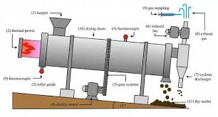 | Length: 12 feet, Dia: 28”  Motor: 5 H.P. with driver,  Hooper needs to fit to feed bamboo chips.  Waste bamboo will be used as fuel for flue gas.  Blower Power: 3H.P
2 | Ribbon Blender | 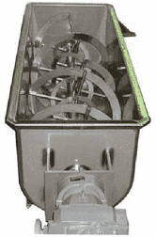 | - Mild steel fabricated with gearbox attachment  - Power: 3 HP  - Capacity: 50 kg mixture
3 | Packeting Machine | 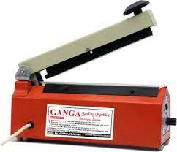 | - Sealing of packet of bamboo stick and incense stick
4 | Weighing Machine | 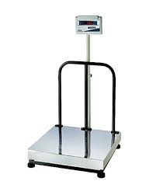 | - Capacity: 100 kg  - Platform size: 2 feet x 2 feet
5 | Pulverizer, Impact type- Hammer Mill, chamber size | 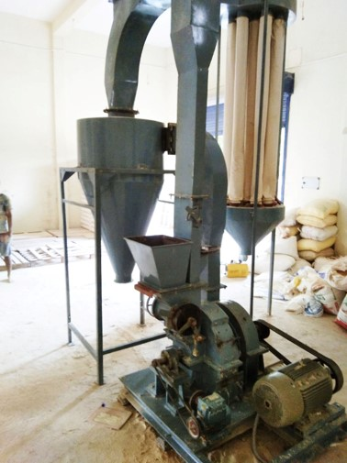 | Motor: 20H.P  With Airlock valve, gearbox  Dust collector & vibropads  Control Pannel adjustment
6 | Pulveriser, Chipping Unit | 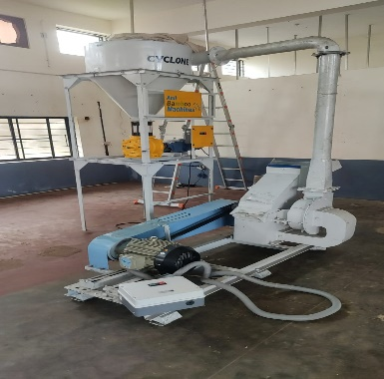 | Motor:12.5 HP  With Airlock valve, gearbox  Dust collector & vibropads  Control Pannel adjustment
7 | VibroSifter, 30" | 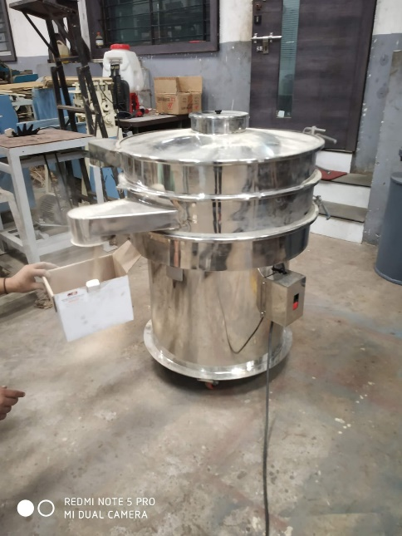 | Motor : 1 H.P
8 | Pellet Making machine |  | Motor: 5H.P  Ability to make pellet from bamboo dust,
9 | Pellet dryring Machine | 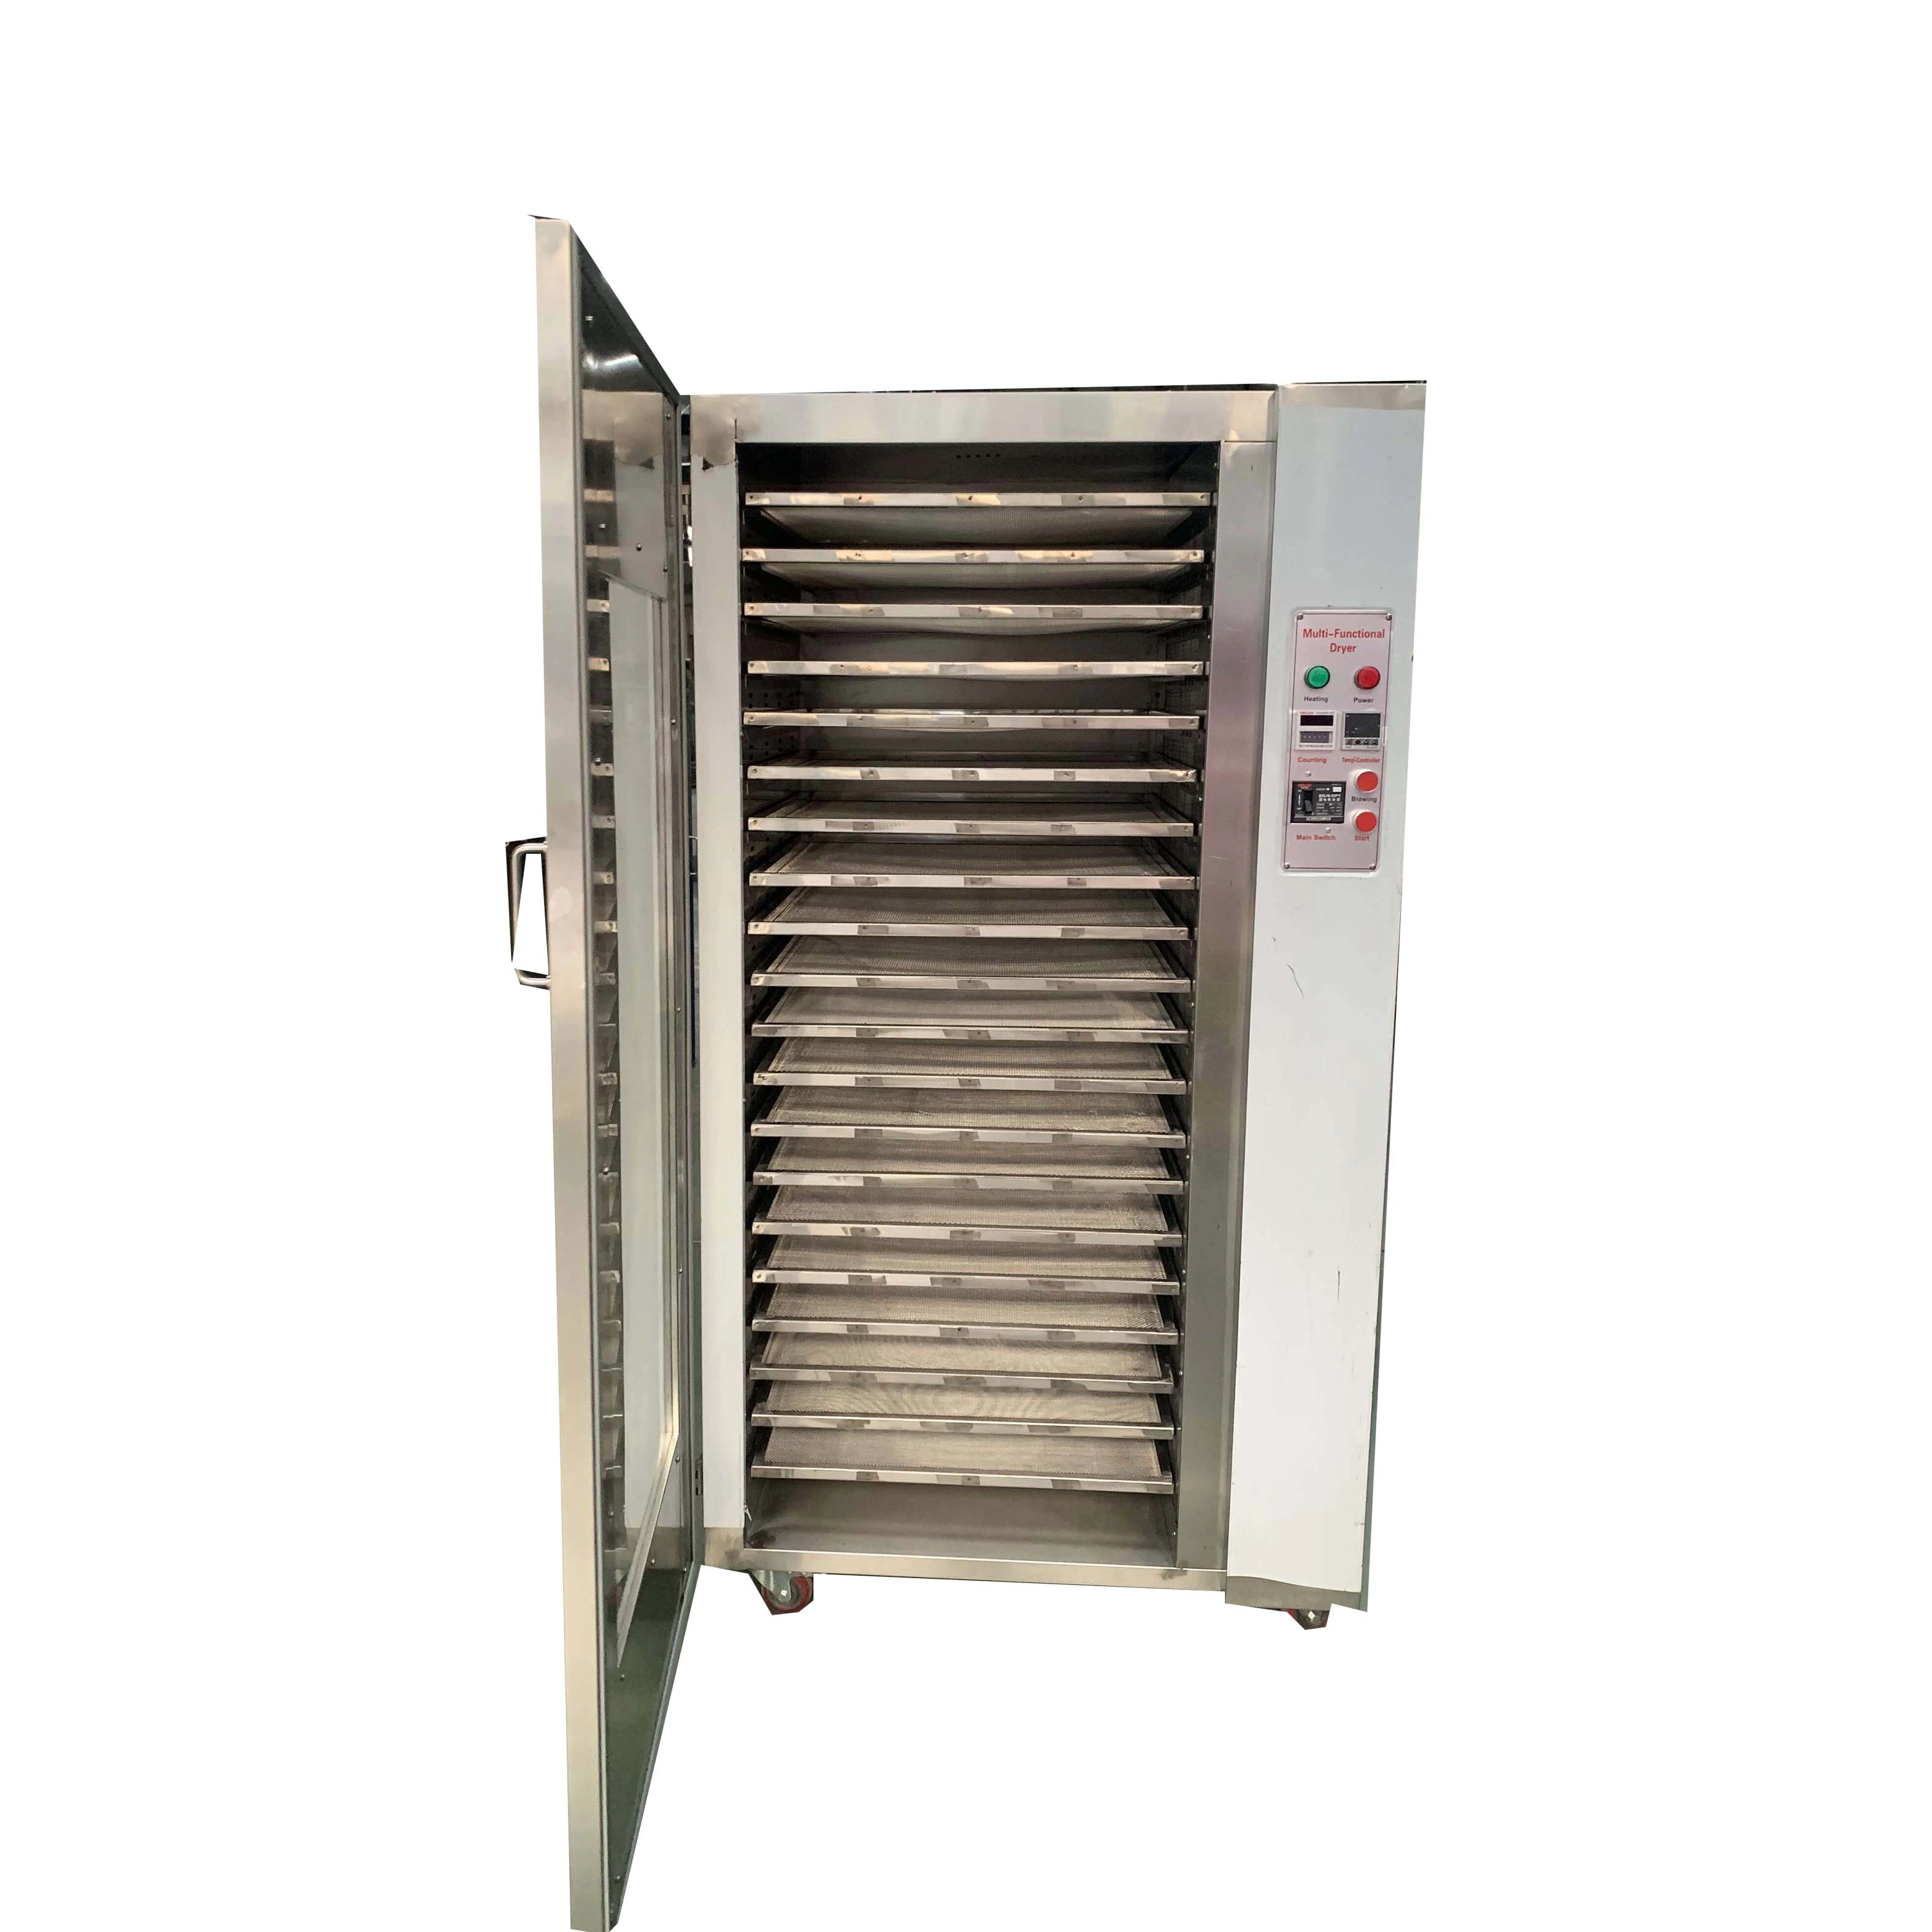

SECTION 3: CRITERIA FOR EVALUATION
All evaluation processes will be carried out by an Evaluation Committee to be formed by NECBDC for this purpose. The decision of the Tender evaluation committee shall be final and no correspondence will be entertained outside the process of negotiation by the Committee. Evaluation of the bid documents will be a 3-stage process as shown below.

3.1 Stage 1: Technical Bid
First, the Technical Proposal will be evaluated of Bidders who do not meet the necessary requirement of technical bids commercial bids will be returned without opening.
At this stage, the documents submitted by the bidders as part of the technical qualification criteria are as follows:
Technical Bids
# | Criteria | Documents to be submitted
1 | Tender fees of Rs.1000/- | Tender fees in the form of Cash / Demand Draft from a Nationalized bank or a Scheduled bank, in favour of “NECBDC” payable at Guwahati
2 | EMD fees of Rs.1,00,000/- | EMD fees in the form of Demand Draft/BG from a Nationalized bank or a Scheduled bank, in favour of “NECBDC” payable at Guwahati  Note: EMD exempted for all bidders who are registered under Ministry of MSME and having Udyog Aadhar. Eligible bidders will have to submit proof of being MSME
3 | Minimum 3 years of existence | Incorporation Certificate / Registration Certificate as a proprietorship / partnership / Pvt. Ltd. firm
4 | Experience of design, build and installation of similar machineries with any Central or State Government Ministry / Department / Agency | Previous Work Order / Agreement / MoU copy
5 | Minimum average turn-over for last three FYs (2020-21, 2021-22, 2022-23) should not be less than 3 Cr. | CA certificate for Turn over  ITR for FY20-21, 21-22, 22-23
6 | The bidder should not have been blacklisted by any institution of the Central or State Government in India on ground of involvement of the bidder in corrupt or fraudulent practices for the last 5 years | Self-declaration by the authorized signatory as per Annexure-II
7 | Business Compliant | Bidder to furnish  1. GSTN certificate  2. Trade license

3.2 Stage 2: Commercial Bid Evaluation
- The Commercial Bids of only technically qualified bidders will be opened on the same date in the presence of bidder representatives.
- Only fixed price commercial bids indicating total price for the deliverables specified in this bid document will be considered.
- Prices shall be quoted in Indian Rupees, inclusive of all prevailing taxes, levies, duties, etc. both in figure and words rounded to one rupee.
- Any conditional bid would be rejected.
- No escalation of cost is allowed during the validity of the contract period.
- Errors & Rectification: Arithmetical errors will be rectified on the following basis: “If there is a discrepancy between the unit price and the total price that is obtained by multiplying the unit price and quantity, the unit price shall prevail and the total price shall be corrected. If there is a discrepancy between words and figures, the amount in words will prevail”.
- If there is no price quoted for the deliverables, the bid shall be declared as disqualified.

ANNEXURES

Annexure-I: Cover Letter [On bidder letter head]
To,
The Managing Director
North East Cane and Bamboo Development Council
G.S Road, Burnihat, Guwahati, Assam-793101

Subject: Tender for the Supply and installation of Bamboo Animal feed-making machine including 6 months of onsite comprehensive warranty.
Sir,
With reference to your RFP document no_____________ dated *****, I/we, having examined the Bidding Documents and understood their contents, hereby submit my/our Bid for the aforesaid Project. The Bid is unconditional.
- I/ We acknowledge that the NECBDC will be relying on the information provided in the Bid and the documents accompanying the Bid for selection of the successful bidder for the Project as mentioned earlier, and we certify that all information provided therein is true and correct; nothing has been omitted which renders such information misleading; and all documents accompanying the Bid are true copies of their respective originals.
- I/ We shall make available to the NECBDC any additional information it may find necessary or require to supplement or authenticate the Bid.
- I/ We acknowledge the right of the NECBDC to reject our Bid without assigning any reason or otherwise and hereby waive, to the fullest extent permitted by applicable law, our right to challenge the same on any account whatsoever.
- I/ We declare that:
- I/ We have examined and have no reservations to the RFP Documents, including any Corrigendum issued by the NECBDC; and
- I/ We do not have any conflict of interest in accordance with provisions of the RFP document; and
- I/ We have not directly or indirectly or through an agent engaged or indulged in any corrupt practice, fraudulent practice, coercive practice, undesirable practice or restrictive practice
- The undertakings given by us along with the Proposal in response to the RFP for the Project were true and correct as on the date of making the Proposal and are also true and correct as on the Proposal Due Date and I/we shall continue to abide by them.
- I/ We agree and undertake to abide by all the terms and conditions of the RFP document
- I/ We shall keep this offer valid for 180 days from the date of opening of pre-qualification bid as specified in the RFP.
We, the undersigned, offer to provide the services for the Project in accordance with your Request for Proposal dated [Date], and our Financial Proposal.

Thanking you,

Yours faithfully (Authorized Signatory’s Signature)

Annexure-II: Declaration that the bidder has not been blacklisted [On Rs.100 non-judicial stamp paper]
To,
The Managing Director
North East Cane and Bamboo Development Council
G.S Road, Burnihat, Guwahati, Assam-793101

Subject: Tender for the Supply and installation of Bamboo Animal feed making machine including 6 months of onsite comprehensive warranty.
Sir,
We confirm that our ____________, is not blacklisted in any manner whatsoever by any of the Central or State Government in India on any ground including but not limited to indulgence in corrupt practice, fraudulent practice, coercive practice, undesirable practice or restrictive practice for the last 5 years

Place:
Date:
Bidder’s Company Seal: Address:

Authorized Signatory’s Signature:
Authorized Signatory’s Name and Designation:

Note: The Bidder shall necessarily provide a copy of ‘Power of Attorney’ authorizing the signatory for signing the Bid on behalf of the Bidder in its Pre-Qualification Bid.

Annexure-III: Certificate of Conformity [On bidder letter head]
To,
The Managing Director
North East Cane and Bamboo Development Council
G.S Road, Burnihat, Guwahati, Assam-793101

This is to certify that, the service for supply, and installation including 6 months of onsite comprehensive warranty which I shall provide, if I am awarded with the work, are in conformity with the Scope of Work in the Tender document.

I also certify that the price quoted per unit cost basis is inclusive of all the cost factors involved in the execution of the project, to meet the desired standards set out in the conditions of the RFP.

Place:
Date:
Bidder’s Company Seal: Address:

Authorized Signatory’s Signature:
Authorized Signatory’s Name and Designation:

Annexure-V: Format of Bank Guarantee [On Rs.100 non-judicial stamp paper]
To,
The Managing Director
North East Cane and Bamboo Development Council
G.S Road, Burnihat, Guwahati, Assam-793101

Sir/Madam,
WHEREAS (Name of the Bidder) hereinafter “called the Bidder” has undertaken, in pursuance of the RFP No ________________________________ dated _______________ for supply and installation of machines for the production of bamboo animal feed including 6 months of warranty for official use.
AND WHEREAS it has been stipulated by you in the said RFP that the Bidder shall furnish you with a Bank Guarantee by a Nationalized or Scheduled Bank for the sum specified therein as the bid security.
AND WHEREAS we have agreed to give the bidder a Guarantee
THEREFORE WE hereby affirm that we are Guarantor and responsible to you, on behalf of the Bidder, up-to a total sum of _______________________________________ (Amount in words and figures) and we undertake to pay you, upon your first written demand declaring the bidder to be default under the RFP and without cavil or argument, any sum or sums within the limit of (Amount of Guarantee) as aforesaid, without your needing to prove or show grounds or reasons for your demand for the sum specified therein.

This guarantee is valid until the ______________ day of _____________20___

Signature and Seal of Guarantors

__________________________

__________________________

__________________________

Date: _____________________
Address: __________________

