North East Cane and Bamboo Development Council
13 Mile, G S Road, Burnihat, Assam

TENDER DOCUMENT

for

SUPPLY, INSTALLATION & COMMISSIONING OF BAMBOO SPOON MAKING MACHINE IN NE STATES

No. NECBDC/Market-intelligence/391/2025

Date of Published: 22-04-2025

Document Price: Rs.1000/- only

1. BRIEF DESCRIPTION:

North East Cane and Bamboo Development Council (NECBDC), an apex body working in the bamboo sector under the North Eastern Council, Ministry of DoNER, Government of India, invites sealed tenders under two-bid system (Technical & Financial) from reputed manufacturers/suppliers for the supply, installation, and commissioning of machines for the production of bamboo spoons and other innovative bamboo products.

2. PARTICULARS OF TENDER:

1. TENDER No. : NECBDC/Market-intelligence/391/2025

2. Name of the work : Supply, installation & commissioning of bamboo spoon making machine in NE States.

3. Period of work : 45 days from the date of issue of Work Order

4. Cost of TENDER : Rs 1000/- in Cash or Demand Draft.
document

5. Last date and time of
Submission of TENDER
(by hand/courier/ post) : 12-05-2025

6. Security Money : The Successful bidder will have to deposit 3% of the project cost as security money to NECBDC before the commencement of the works.
Note: EMD exempted for all bidders who are registered under the Ministry of MSME and having Udyog Aadhar. Eligible bidders will have to submit proof of being MSME

7. Period of validity of : 21 Days

8. Date and time of
opening of TENDER : 13-5-2025 at 4pm

9. Place of opening of
TENDER : North East Cane and Bamboo Development Council,
13th Mile, G.S. Road, Burnihat, Assam.

3. SUBMISSION OF TENDER

3.1 SEALING AND MARKING OF TENDER:

3.1.1 The TENDER must be complete in all aspect and should contain requisite certificate, drawings, informative literature etc. as required in the specification.

3.1.2 This is a two-part bid consisting of a Technical bid and a financial bid. The Technical and Financial bids should be sealed in separate envelopes and then to be sealed in one Envelope superscribing on the envelope, “Quotation for Supply, installation & commissioning of bamboo Spoon making machine”
The bid shall include:
a. Forwarding letter by the Tenderer
b. Bid Documents
c. All required supporting documents
d. EMD

3.1.3. TENDER should be addressed to: -

Managing Director
North East Cane and Bamboo Development Council
13th Mile, G.S. Road, Burnihat, Assam-793101

- The TENDER should be submitted at the office of North East Cane and Bamboo Development Council, on & before 3.00 PM, 12-05-2025.

- Tenders may be received through Post/courier/by hand. NECBDC will not be responsible for any delay or misplace in postal transit.

- Tenders can also be deposited personally in the Tender Drop Box at NECBDC.

d. Title and Tender no. should be written on the top of the sealed envelope.

3.2 EXPENSES OF AGREEMENT:

All the expenses of completing the agreement, including the cost of stamp or any other kind of expenditure incurred in the process of TENDER submission till final compliance shall be borne by the Tenderer.

3.3 LATE BIDS:

Any TENDER received after the deadline for submission of TENDER prescribed by NECBDC, Burnihat at shall be rejected and / or returned unopened to the Tenderer.
3.4 GENERAL TERMS & CONDITIONS:

1. Quotations are to be submitted in ONE SEALED ENVELOPE containing one sealed technical bid and another containing the financial bid.
2. The NECBDC will contact only the successful bidder.
3. The NECBDC reserves the right to split the works among two or more parties depending on the nature of the machine and process requirement.
4. The rates quoted against the specifications mentioned in the bid should be inclusive of all taxes and charges and will not be negotiable.
5. The bidders may, specifically indicate/mention if any higher specifications are offered.
6. EMD: 1% of the quoted value in the form of DD to be submitted along with the bid documents in case of non-MSME vendors.
7. Security money of 2% of the total value in the work order must be deposited by the successful bidder before the commencement of the work.
9. The Decision to accept the quotation will lie with the competent authority of North East Cane and Bamboo Development Council, who does not bind himself to accept the lowest quotation and who reserves the right to himself to reject or partially accept any or all quotations received, without assigning any reason thereof.

4. TENDER OPENING:

4.1 OPENING OF TENDER:

The tender bids received will be opened on the date and time mentioned above in presence of the bidders or their representatives. Only a single person following all SOP will be allowed entry into the room.

4.2 CLARIFICATION OF TENDER:

4.2.1 To assist in the examination, evaluation and comparison of TENDER, NECBDC may at its discretion, ask the Tenderer for a clarification on the TENDER which is submitted by him. The request for clarification and the response shall be in writing.
4.2.2 NECBDC will be at liberty to involve any expert or consultant in evaluating the bid for completing the entire bid process.

5. AWARD OF CONTRACT:

5.1 RESERVATIONS AND CRITERIA

- The Tenderer should pass in all items of “Eligibility Criteria”. Eligible tenderer quoting the lowest offer price shall be awarded the contract.
- NECBDC reserves the right of negotiation with eligible Tenderers before the finalisation of the TENDER process.
- NECBDC reserves the right at the time of award of contract to increase or decrease the numbers of works without any change in terms and conditions.
- NECBDC reserves the right to accept any bid and to reject any or all bids or accept any TENDER in total or in parts or to split the work among various Tenderers without assigning any reason thereof.
5.2 ELIGIBILITY CRITERIA

5.2.1. The applicant should have executed similar or larger-scale projects of supply, installation and commissioning of bamboo processing machineries or have the capabilities to do this similar type of jobs.
5.2.2. Applicants should have prior experience or have executed a minimum of 3 projects in the North East Region.

6. NOTIFICATION OF AWARD

Prior to the expiration of the period of TENDER validity, the Centre will inform the Tenderer by registered letter, by phone or fax or by e-mail that the bid has been accepted and the work has been awarded.

7. EXECUTION PERIOD

The entire work shall be completed in all respect within 45 days from the date of award of work. In case the project cannot be completed in 45 days, bidders are required to mention the same in the bid document with justifications.

8. HOW TO APPLY:

8.1 COVERING LETTER:
(To be typed in the company’s letter head)

To
The Managing Director
North East Cane and Bamboo Development Council
13 Mile, G.S. Road, Burnihat, Assam
PIN – 793101(Assam)

Sub: Supply, installation & commissioning of bamboo spoon making machine in NE States

Dear Sir,

With reference to your TENDER notice dated ……………. I have examined the TENDER document and understood its contents. I hereby submit my Bid for the supply, installation and commissioning of bamboo spoon making machine in NE States .

1. The Application is unconditional for the said Tender.
2. It is acknowledged that the Authority will be relying on the information provided in the tender and the documents accompanying such tender for qualification of the bidders for the above-mentioned project, and we certify that all information provided in the tender and in Annexures are true and correct; nothing has been misrepresented and omitted which renders such information misleading; and all documents accompanying the bid are true copies of their respective originals.
3. This statement is made for the express purpose of the above-mentioned subject.
4. We shall make available to the Authority any additional information it may find necessary or require supplementing or authenticate the qualification statement.
5. We acknowledge the right of the Authority to reject our bid without assigning any reason or otherwise and hereby relinquish, to the fullest extent permitted by applicable law, our right to challenge the same on any account whatsoever.
6. It is declared that:
(a) We have examined and have no reservations in the Tender document
(b) We have not directly or indirectly or through an agent engaged or indulged in any corrupt practice, fraudulent practice, coercive practice, undesirable practice or restrictive practice in respect of any Bid or request for proposal issued by or any agreement entered into with the Authority or any other public sector enterprise or any government, Central or State.
7. It is understood that NECBDC may cancel the Bidding Process at any time without incurring any liability and that you are neither bound to invite the applicants to Bid for the project nor to accept any bid that you may receive.
8. It is certified that we have not been convicted by a Court of Law or indicted or adverse orders passed by a regulatory authority that could cast a doubt on our ability to undertake the Project or which relates to a grave offence that outrages the moral sense of the community.

9. It is further certified that no investigation by any regulatory agency is pending against us.

10. It is hereby affirmed that we comply/ shall comply with the maintenance requirements for one year.

11. We hereby irrevocably relinquish any right or remedy which we may have at any stage at law or howsoever otherwise arising to challenge or question any decision taken by the Authority in connection with the selection of bidders, selection of the Tenderer, or in connection with the selection/ Bidding Process itself, in respect of the above-mentioned Project and the terms and implementation thereof.

12. We agree to undertake to abide by all the terms and conditions of the TENDER
Document.

13. We agree to undertake to be liable for all the obligations of the Tenderer under the Agreement

. In witness thereof, we submit this application under and in accordance with the terms of the TENDER document.

Yours faithfully,

(Signature, name and designation of the Authorized Signatory)
SEAL

9. PARTICULARS OF TENDERER :

1. Name of firm/company: :
2. Communication address: :
3. Telephone, Telex, Fax No :
5. E-mail :
6. Web site :
7. Name and designation of the representative
of the Tenderer to whom all references/
communications shall be made :
8. Amount of earnest money/bid security
deposited with instrument no / bank and date :
10. Firm Registration number / details :
11. Copies of ITR acknowledgement :
12. GST Registration no :
13. Status of the applicant : Manufacturer/Dealer/OEM/Others
15. Previous experience or work done by the
Tenderer of similar nature of project. :
16. Name and address of the manufacturer/
Authorized dealer (please attach
authorization certificate in case of
non-manufacturing company). :

(Signature of Tenderer)
with seal

10. EXPERIENCE:
(Details of Each Project) Use different sheet per project.
Item
1. Title of the project

2. Location

3. No. of works/projects completed

4. Entity/ Agency with which project has been executed

5. Date of commencement of the project

6. Date of completion/ commissioning

7. Cost of the Project

8. Scope of Work

11. Instructions:

- Tenderers are expected to provide information concerning only Eligible/Qualified
- Projects.
- Information provided in this section is intended to serve as a backup for information provided in the TENDER.
- An authentic experience certificate should be annexed concerning each eligible/qualified Project from the Agency for which the project is executed.
- Provide the estimated capital cost of each Eligible/Qualified Project.

12. Checklist:
- Company/Firm registration Certificate.
- GST Registration Certificate
- Income Tax Return acknowledgements
- Photocopy of PAN Card
- Factory license (compulsory)
- Labour and environmental clearance certificates wherever applicable.
- List of Technical Staff (technical competency for manufacturing)
- List of projects completed – completion certificates
- Self-declaration on letterhead that the company/firm is not blacklisted by any agency
- Audited Statement of Accounts
- EMD
- DD for Rs 1000/- toward the cost of Tender Document in favour of
“North East Cane and Bamboo Development Council”
- Catalogue / leaflet / of machines produced by the company.
- Note: Any technical queries regarding the specifications of the machineries, functions, end products, queries may kindly be sent to cbtcassam@gmail.com/necbdc@gmail.com mentioning the Tender Number.

SPECIFICATIONS OF MACHINE:

Sl NO | Name of the Machine  15. MACHINE DETAIL WITH SPECIFICATION & ESTIMATED COST | Specification | Picture | Quantity
1 | Round Bamboo Cross Cutting Machine ( Heavy Duty) | heavy duty. including 2 h.p. motor, starter and carbide tipped circular saw 16” x 3 mm x 120 teeth  Maximum diameter of Bamboo to be cut : 200mm (8”)  - Power consumption : 2 H.P  - Spindle Speed (Minimum) : 2800 rpm  - ISI mark motor with starter  - Required Intake and out feed table | 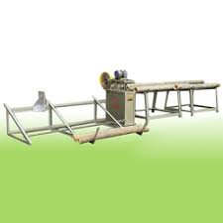 | 1
2 | Out Side Node Removing machine | One table with adjustable height and one cutter should exist  Power : 2 H.P |  | 1
3 | Inside knot removing cum width sizing cum two side planning cum slicing machine | Two top and two bottom cutters including inside knot removing, width sizing adjustment  - Power consumption : 3 H.P x 2nos  - 2 H.P x 3nos  - Speed (Minimum) : 8 rpm  - ISI mark motor with starter | 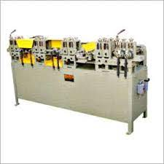 | 1
4 | Drying Chamber | Construction Size 15 cubic meter  Wastage bamboo will be used as fuel  Power Consumption : 3 H.P | 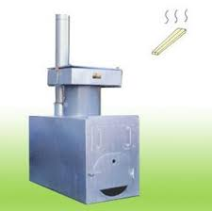 | 1
5 | Boiling Tank/Dipping Tank | Made with Stainless Steel  Size of Tank : 8’ x 2’ x 2’ | 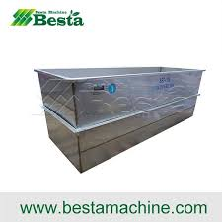 | 1
6 | Air Compressor | Oil lubricated compressor  Maximum pressure :12kg/cm2  Working pressure :2-3 kg/cm2  Number of unit : 1 no  Power : 10 H.P  Capacity : 38 CFM  Tank Capacity : 200 litre |  | 1
7 | Universal Grinding Machine | Able to sharp all kind of cutter  Water cooling system is connected  Diamond Wheel is required to sharp carbide tips  Power : 2 H.P x 1 no & ½ H.P x 1 no | 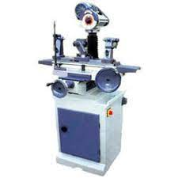 | 1
8 | Hydraulic pallet Truck | Manually operated  Maximum Capacity : 2 Tons | 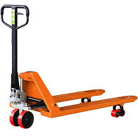 | 1
9 | Vertical sponge sander | Power : 2 H.P  Sanding belt size: 152 X 635mm (6” x 25”)  Table tilt : 45 degree | 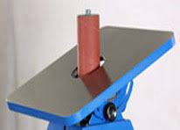 | 1
10 | Horizontal Vertical Sander | Sanding Belt Size: 150x1220/6” x48’  Sanding Disc Size: 254/10”  Table Size: 750 x 254/29.5” X 10”  Spindle RPM: 1400  Power: 1.5HP | 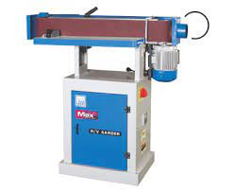 | 1
11 | Profiling Machine(square shovel) | Power Supply: 3~ 380VAC Motor power：8kw  Size:1600×1200×1100  Weight：400kg | 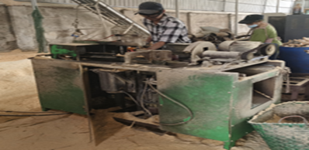 | 1
12 | Double-sided Planer | Power Supply: 3~ 380VAC Motor power：6kw  Size:1000×900×1200  Weight：300kg | 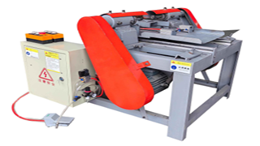 | 1
13 | Coring Machine | Power Supply: 3~ 380VAC Motor power：6kw  Size:1000×900×1200  Weight：300kg |  | 1
14 | Manual Sanding Machine | Power Supply: 3~ 380VAC Motor power：2.2kw  Size:900×400×700  Weight：100kg |   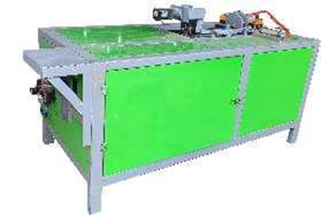 | 1
15 | Automatic Drilling Machine | Power Supply: 3~ 380VAC Motor power：1.5kw  Size:1200×500×700  Weight：150kg | 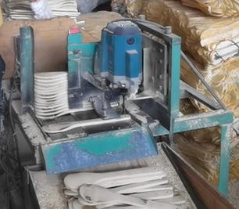 | 1
16 | Triangle Type Bamboo Slicing Machine | Power Supply: 3~ 380VAC Motor power：4kw  Size:1500×800×800  Weight：350kg | 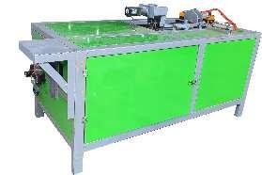 | 1
17 | Bamboo Broom Making Machine | Bamboo broom cane be binded automatically by wire /plastic Rope etc . Production capacity should be not less than 500/hr |  | 1
18 | Automatic Mini Lathe Machine | Bamboo pieces can be turned automatically. CNC operated. Multiple designs can be made. | 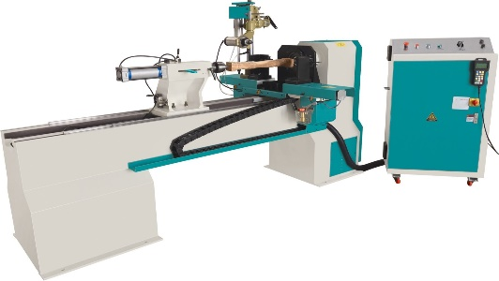 | 1
19 | Laser Engraving Machine | Co2 laser tube, size 2feet x 3feet. Ability to cut bamboo board up to 10 mm to 12 mm . Rotary adjustment system should be connected. | 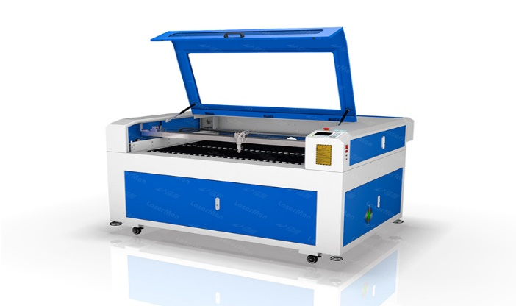 | 1

